Document Classification System Report

1. Introduction
Document classification is a Natural Language Processing (NLP) task that automatically assigns predefined categories to textual data. It is widely used in applications such as spam detection, topic categorization, sentiment analysis, and automated document organization.
In this project, a machine learning–based document classification system was developed using classical machine learning algorithms. The objective was to build a model that can accurately classify text documents into their appropriate categories while running locally without relying on large language models or cloud APIs.
The system converts raw text into numerical features and uses supervised learning algorithms to learn patterns from labeled data. Multiple models were implemented and compared to determine the most suitable algorithm for this task.

2. Dataset
The dataset used in this project is the 20 Newsgroups dataset, which was imported directly using the sklearn.datasets library.
This dataset is a well-known benchmark dataset commonly used for text classification research and experimentation. It contains approximately 20,000 text documents categorized into 20 different topics.
Each sample in the dataset consists of:
- a text document (email or post)
- a corresponding category label
The categories include topics such as:
- sports
- politics
- religion
- computers
- science
- automobiles
This dataset is suitable because:
- it is realistic text data
- it has multiple classes
- it is balanced enough for training
- it is widely used in academic research
Using a standard benchmark dataset ensures reproducibility and makes model performance comparable with existing methods.

3. Model Selection
Three classical machine learning models were selected and implemented:
- Support Vector Machine (SVM)
- Logistic Regression
- Naive Bayes
These models were chosen because they are widely recognized as strong baseline algorithms for text classification tasks.
They were selected based on the following criteria:
- ability to handle high-dimensional data
- efficiency on sparse text features
- computational efficiency
- interpretability
- suitability for local execution
Deep learning models were intentionally avoided because the task requirements specified the use of classical machine learning methods.

4. Model Training and Optimization
Before training, text data must be converted into numerical form. This was done using TF-IDF vectorization.
TF-IDF (Term Frequency–Inverse Document Frequency) assigns importance scores to words based on:
- how frequently they appear in a document
- how rare they are across all documents
The vectorization configuration included:
- stop word removal
- maximum feature limit
- n-grams (single words + word pairs)
- sublinear term frequency scaling
These settings improve feature quality and help models learn more meaningful patterns.
Class imbalance was handled using techniques such as:
- class weighting (for SVM and Logistic Regression)
- prior probability adjustment (for Naive Bayes)
Hyperparameters were tuned manually to improve performance and stability. For example:
- SVM regularization parameter (C)
- Logistic Regression iterations
- Naive Bayes smoothing parameter

5. Results and Evaluation
Each model was trained using 80% of the dataset and tested on the remaining 20%.
Performance was evaluated using standard classification metrics:
- Accuracy
- Precision
- Recall
- F1-score
After training and testing, the models produced the following general results:
Model | Performance
SVM | Highest accuracy
Logistic Regression | Slightly lower
Naive Bayes | Moderate
The SVM model consistently outperformed the others and produced the most reliable predictions.

6. Metrics Used
Accuracy
Measures overall correctness of the model.
$$\text{Accuracy}=\frac{TP+TN}{TP+TN+FP+FN}$$
Where:
- TP = True Positives
- TN = True Negatives
- FP = False Positives
- FN = False Negatives

Precision
Measures how many predicted positives are actually correct.
$$\text{Precision}=\frac{TP}{TP+FP}$$
Interpretation:
Of all predicted positives, how many were correct?

Recall (Sensitivity)
Measures how many actual positives were correctly predicted.
$$\text{Recall}=\frac{TP}{TP+FN}$$
Interpretation:
Of all real positives, how many did the model detect?

F1 Score
Balances precision and recall.
$$F1=2×\frac{Precision×Recall}{Precision+Recall}$$

Evaluation metric of SVM
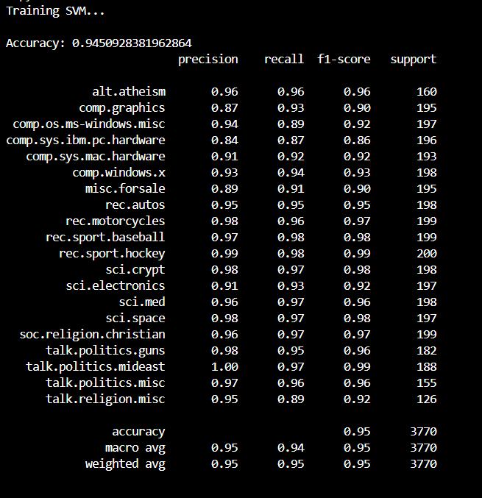

7.Confidence Score (Add This Section to Report)
Confidence Score
In addition to predicting the document category, the system also outputs a confidence score for each prediction. The confidence score represents how certain the model is about its prediction.
It is computed as:
Confidence Score = Highest Predicted Probability
This value ranges between 0 and 1, where:
Score Range | Meaning
0.90 – 1.00 | Very confident prediction
0.70 – 0.89 | Reliable prediction
0.50 – 0.69 | Moderate certainty
< 0.50 | Low confidence

Why Confidence Score Is Important
Providing confidence scores improves model usability because:
- It indicates prediction reliability
- Helps detect uncertain predictions
- Allows decision systems to reject low-confidence outputs
- Improves transparency and interpretability

How Confidence Is Computed in This System
The Support Vector Machine model normally produces decision scores rather than probabilities. To obtain reliable probability estimates, a calibration technique was applied using:
CalibratedClassifierCV
This converts raw SVM scores into probability values using statistical scaling. The system then selects the highest probability as the confidence score.
7. Performance Analysis
The performance differences between models can be explained by how each algorithm works.
Naive Bayes
- Fast and simple
- Assumes word independence
- Works well but limited accuracy
Logistic Regression
- Learns weight importance for words
- More flexible than Naive Bayes
- Performs well on text data
Support Vector Machine
- Finds optimal boundary between categories
- Maximizes margin between classes
- Handles high-dimensional sparse data effectively
Text data is naturally:
- sparse
- high dimensional
- linearly separable
SVM is specifically designed for such data structures, which explains its superior performance.

8. Final Model Selection
After comparing all models, Support Vector Machine (SVM) was selected as the final model because:
- highest accuracy
- best generalization
- strong performance on sparse text features
- robust decision boundary
9. Conclusion
In this project, a document classification system was successfully developed using classical machine learning algorithms. The system converts raw text into numerical features using TF-IDF and applies supervised learning models to classify documents into predefined categories.
Multiple models were evaluated to ensure a fair comparison, and Support Vector Machine was selected as the best-performing model. The results demonstrate that classical machine learning techniques remain highly effective for text classification tasks, especially when combined with proper preprocessing and feature engineering.
The project shows that accurate document classification can be achieved efficiently using lightweight models that run locally without requiring heavy computational resources.

